Intelligent heat pump process monitoring system

[**instruction manual**](C:/Users/Administrator/AppData/Local/youdao/dict/Application/9.1.6.0/resultui/html/index.html#/javascript:;)



Table of Contents

1. System Description 1

2. Login System 3

2.1 User Login 3

2.2 Dashboard 3

2.3 Monitoring Page 4

3. Products 5

3.1 Product List 5

3.2 Create and Edit 5

4. Equipment 8

4.1 Equipment List 8

4.2 Equipment Storage 11

4.3 Equipment Out of the Warehouse 12

5. Events 13

5. 1 Alarm List 13

5.2 Device Logs 13

6. Dealer Management 14

6.1 Dealer List 14

6.2 Create and Edit 14

7. User Management 15

7.1 User List 15

8. System 16

8.1 Account 16

8.2 Role Management 16

8.3 APP Management 17

# 1. System Description

This system mainly provides remote management of various types of air energy products produced by the company, as well as corresponding equipment , data generated by equipment, events, dealers, accounts , etc.

The detailed function description of the system is as follows:

1. Homepage

In the dashboard, according to the status of the equipment in the system, the number of equipment, fault alarms, and statistical information of users are displayed with intuitive icons.

The real-time display of the operation status of all equipment on the map, as well as the statistics of equipment online status and alarm status. You can click the device logo to view the device information.

2. Product Management

You can create and edit the required product, define the function points of the product and select the data that this product needs to pay attention to .

3. Device management

of each device, including the following functions:

* Equipment list: Display all equipment and related properties in real time in the form of a list, and you can view the detailed information of the equipment.
* Equipment storage : Import equipment into the system.
* Equipment out of the warehouse: assign the equipment out of the warehouse to the designated dealer.

4. Incident Management

* Alarm list: Display the alarm records generated by the equipment in the system in the form of a list, and view the details of the alarm processing.
* Device log: display the historical data reported by the device in the form of a list, display the original binary data reported by the device, and analyze and display the binary data.

5. Dealer Management

Manage the dealer account, which can set the associated products for the dealer.

6. User Management

* User list:

It mainly provides the display and editing functions of the user information of the currently logged-in user, as well as the management of registered users using the client APP , including viewing the list of devices bound to the user and releasing the binding relationship between the user and the device.

* User Feedback: It mainly deals with the feedback information submitted by users in the APP.

7. System

* Account management: manage accounts other than dealers in the system, create required roles, and assign roles to accounts.
* Role management: manage the roles in the system, specify the access rights and operation rights of various functions in the system for the roles.
* APP management: manage the corresponding APP information in the system

# 2. Login System

## 2.1 User Login

Enter https://saas.mysmartiot.com/ in the address bar of the browser, and the login page will be displayed by default after the web page opens, as shown in the figure below:

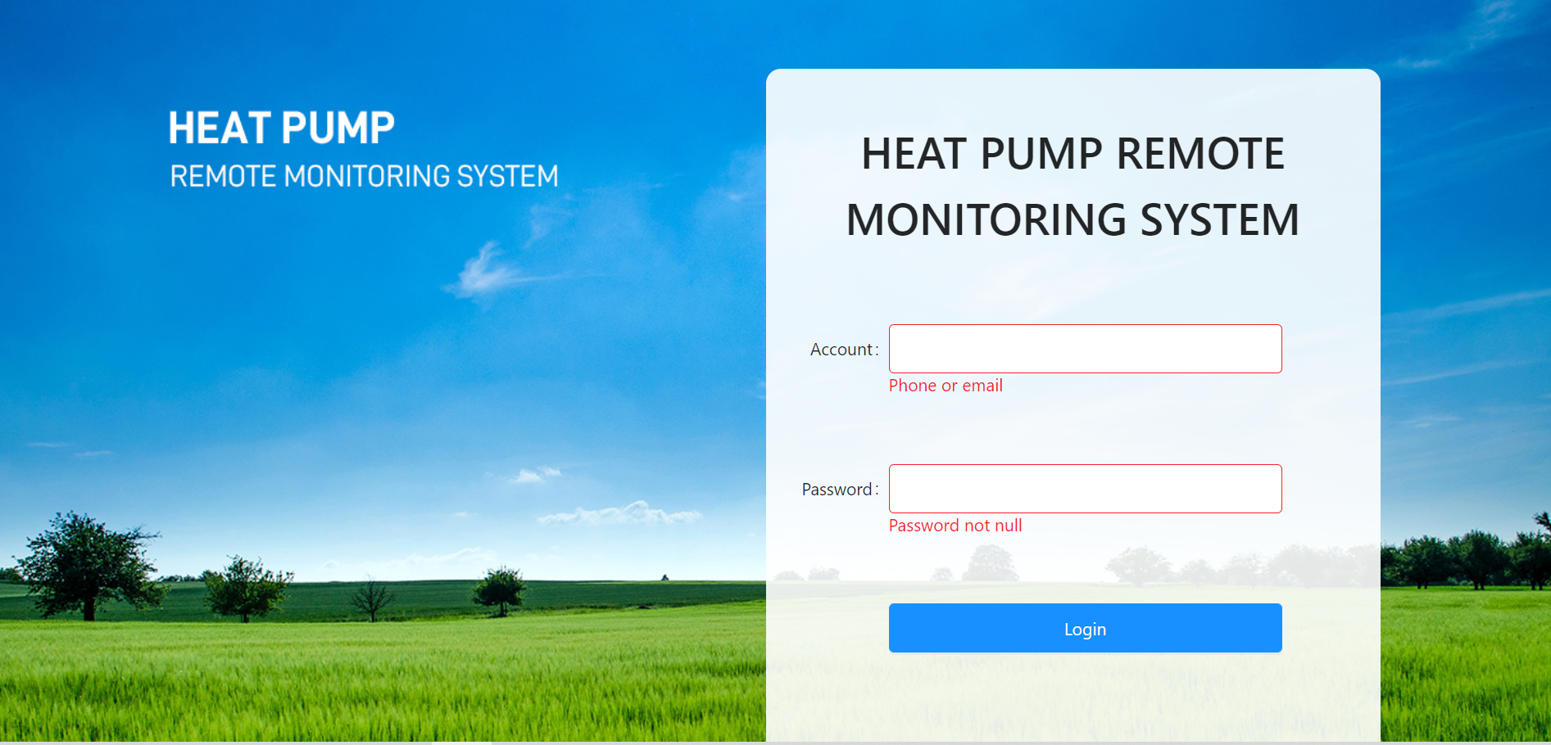

Entering the account name and password required for login , click Login , and enter the system after successful login .

## 2.2 Dashboard

Display device statistics in the form of charts, as shown in the figure below:

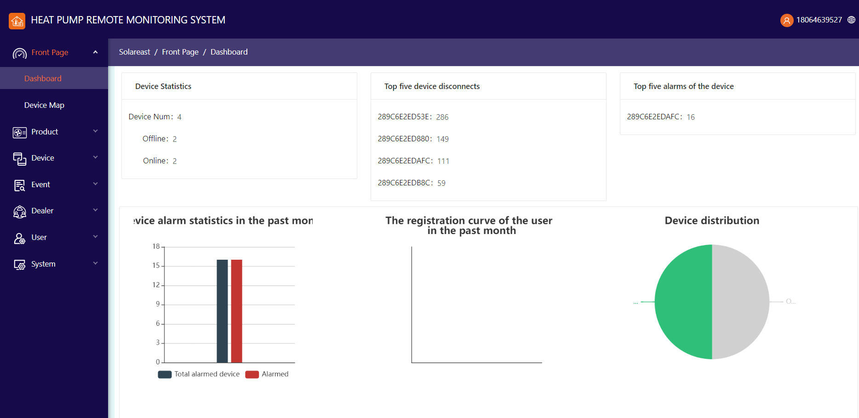

1. Count the number of devices in each state.
2. Count the top five devices with the number of dropped calls and display the number of dropped calls.
3. Count the top five devices with the number of alarms and display the number of alarms.
4. In the form of a bar chart, the device alarm status in the past month and the number of devices in each state are displayed.
5. the proportion distribution of online and offline devices in the form of a pie chart .

## 2.3 Monitoring Page

Display the device associated with the current user on the map according to the location of the device:r

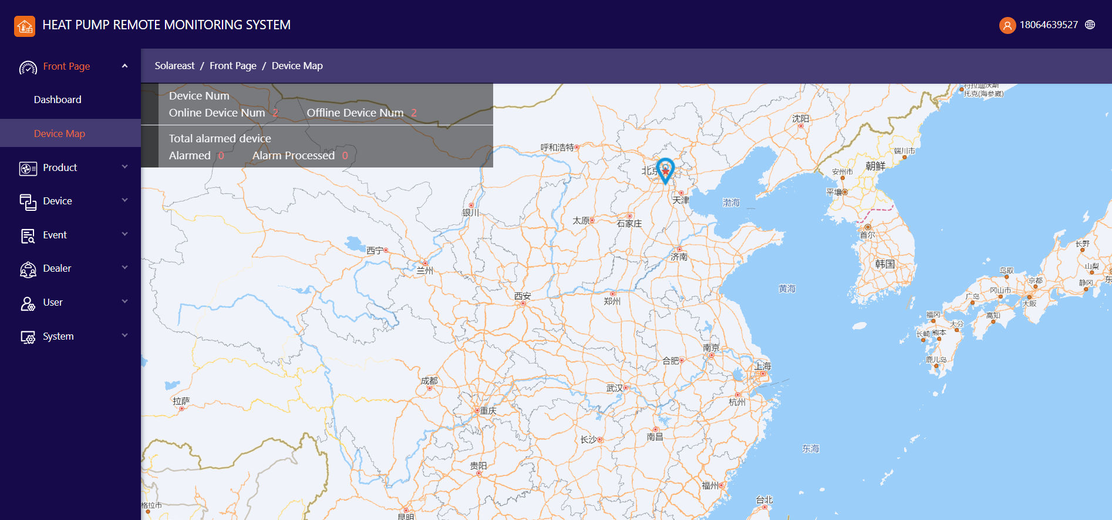

Click the device logo in the map to pop up the relevant information of the device , as shown in the figure above.

# 3. Products

### 3.1 Product List

Types created in the current system in the form of a list. Products can be deleted.

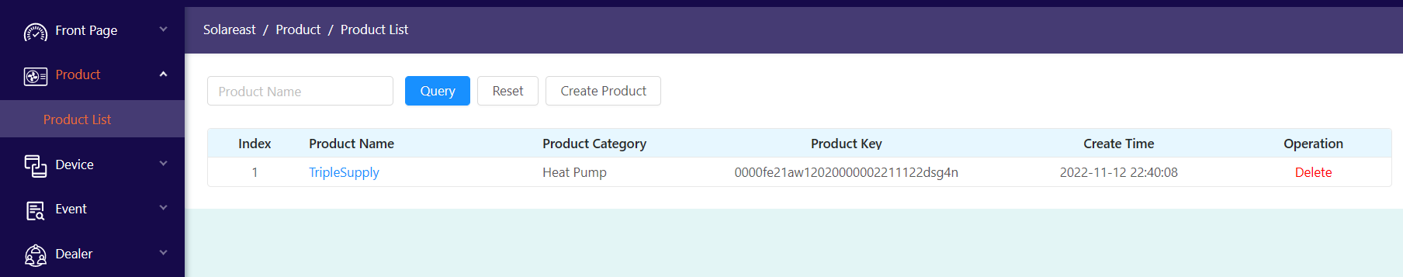

### 3.2 Create and Edit

a) Create Product

Click "Create Product" in the product list to open the product creation page, as shown below:

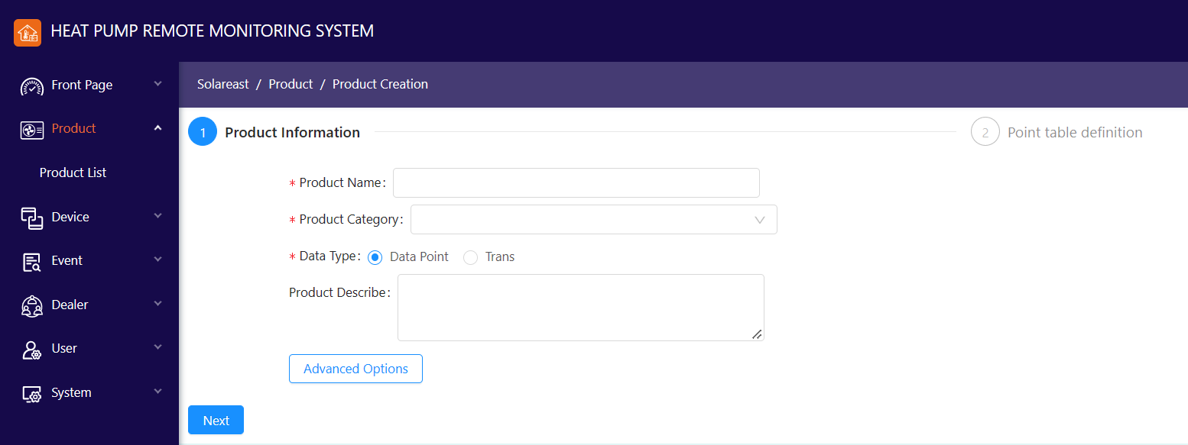

After filling in the required basic information, if the data type selects "Transparent Transmission", click Save to complete the product creation; if the data type selects "Point Table", click Next to edit the point table:

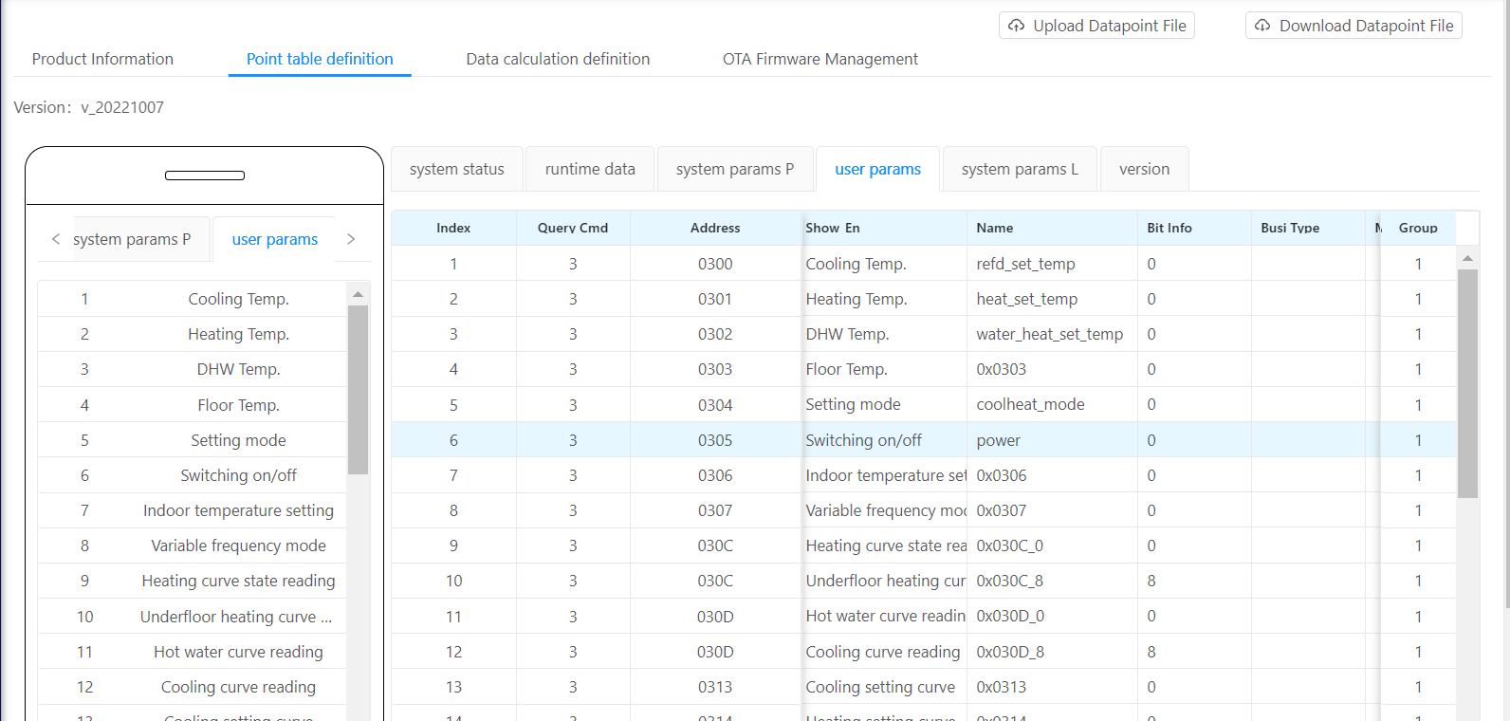

After clicking Finish, the product is successfully created.

b) Product Editing

On the product list page, click an existing product name to enter the product editing page, as shown below:

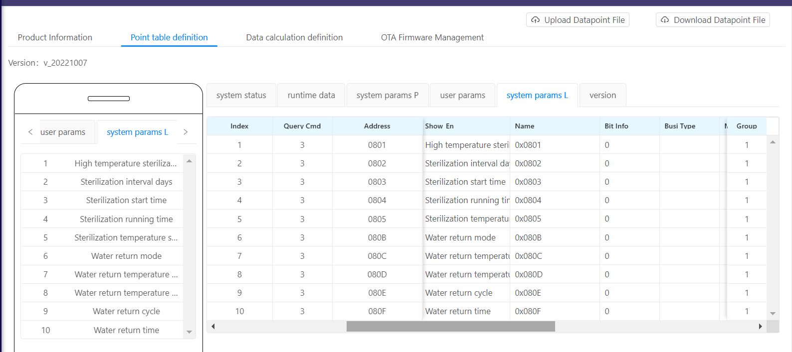

By default, the point table information defined by this product is displayed. The user can download the excel file corresponding to the product point table information by downloading the configuration file, edit it and upload it again to edit the point table.

Users can also modify the basic information of the product on the edit page .

The concerned data can be specified in the "Data Calculation Definition", and the calculation formula can be defined, as shown in the figure below:

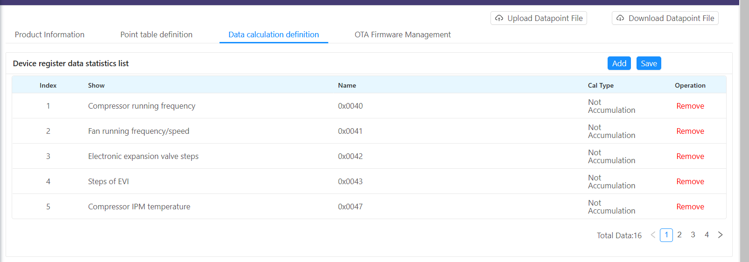

User-selected data can be viewed in the device analytics for individual devices.

# 4. Equipment

### 4.1 Equipment List

Click Device List in the menu to open the Device List page, displaying all devices in the current system :

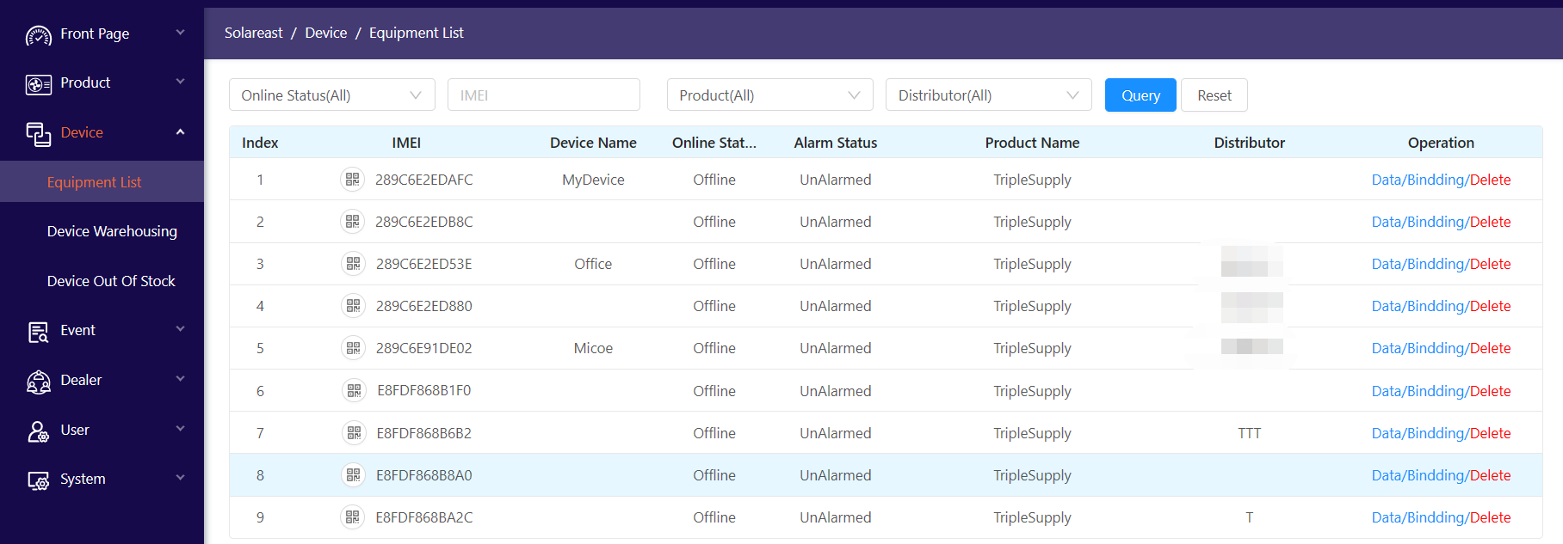

Users can query based on device online status, IMEI , product and dealer, and perform related functions on a single device.

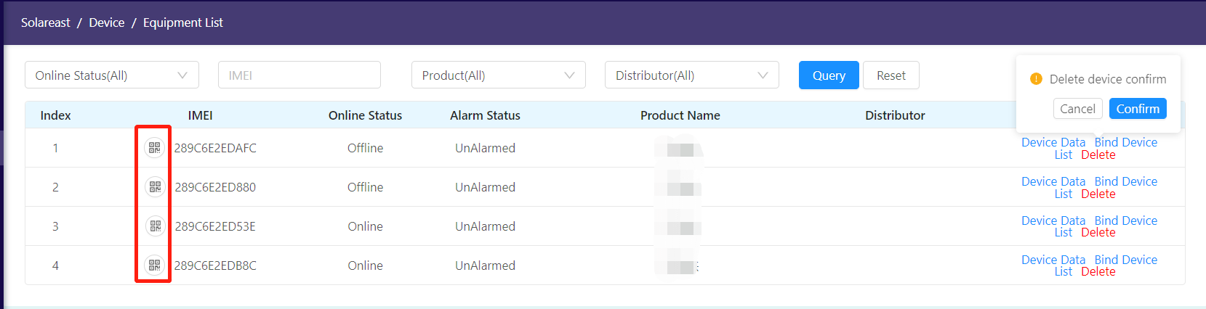

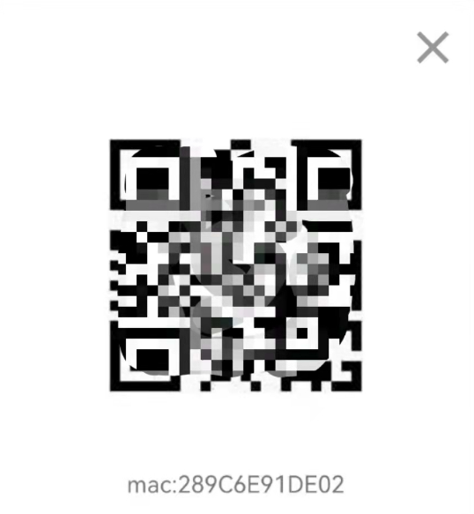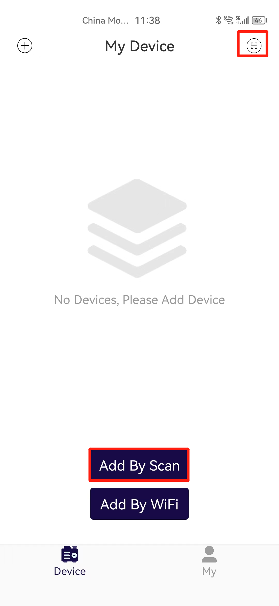

Click the QR code icon at the IMEI to display the shared QR code of the device, and use the mobile APP to scan the code to add this user device and realize the binding.

1. Device Data

Click "Device Data" to see the detailed information of this device, as shown in the figure below:

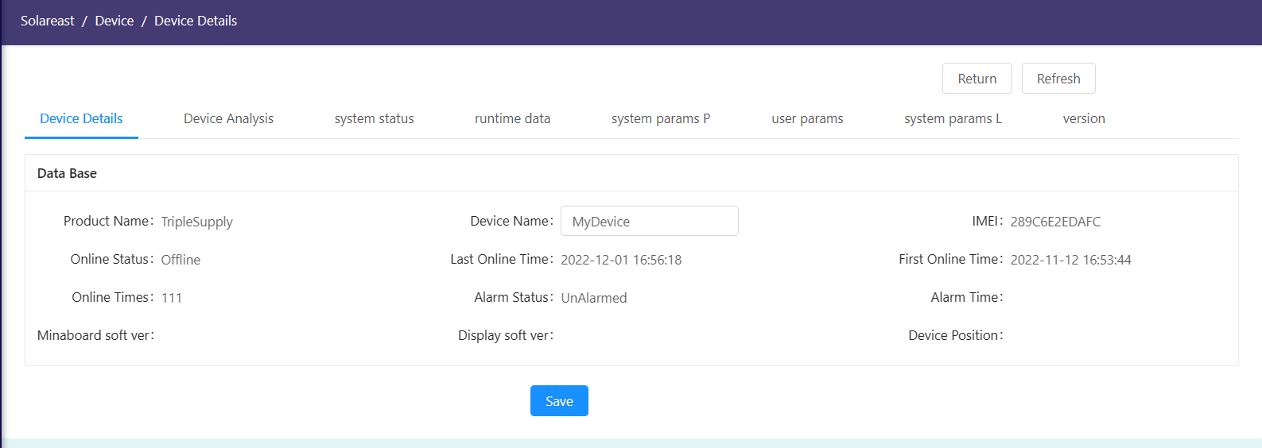

Select different Tab pages to view the corresponding device parameter information:

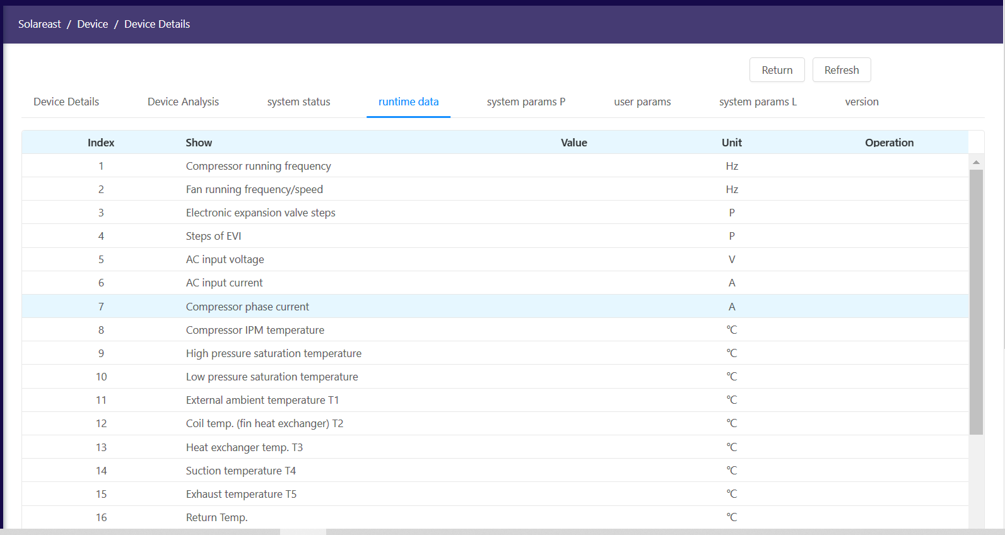

For parameters that can be remotely maintained and modified, new parameters can be set and sent to the device:

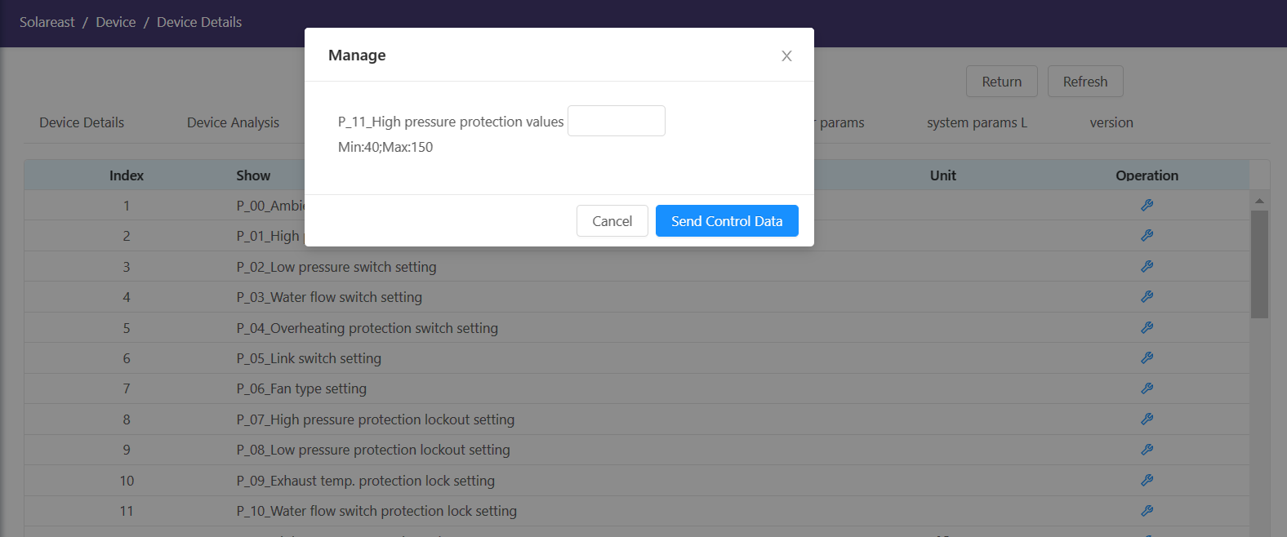

Click "Send Control Command" to send this parameter value to the device.

The Equipment Analysis page is used to plot the data points selected by the user in the product definition:

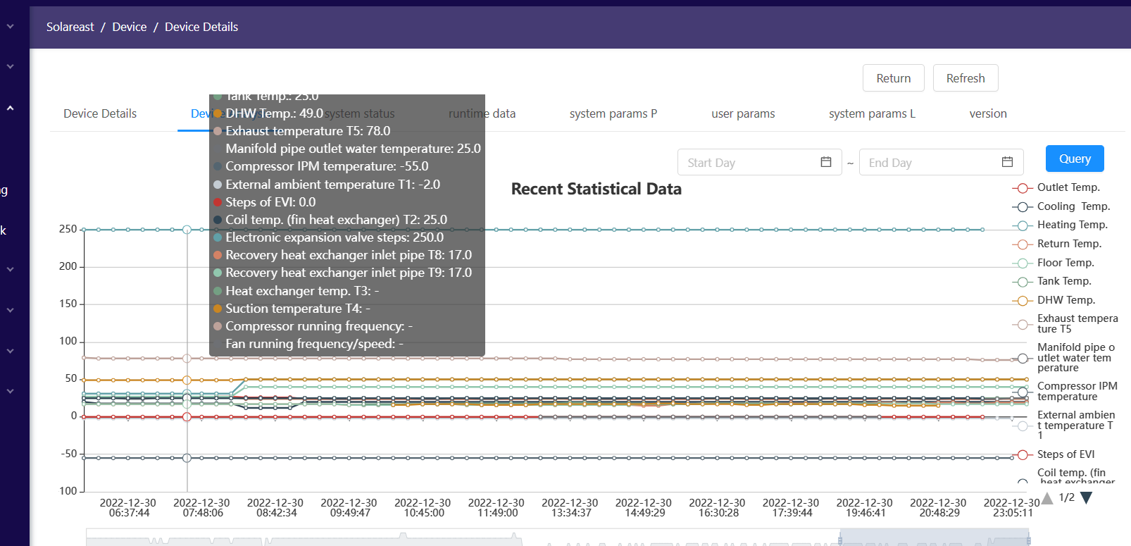

The data corresponding to the time can be queried by setting the time period, the display of parameters can be controlled by clicking the legend, and the display area can be enlarged or reduced by sliding the mouse.

1. Bind user list

Click "Bind List" in the device list to open the device's bound user list page, displaying the list of users bound to this device .

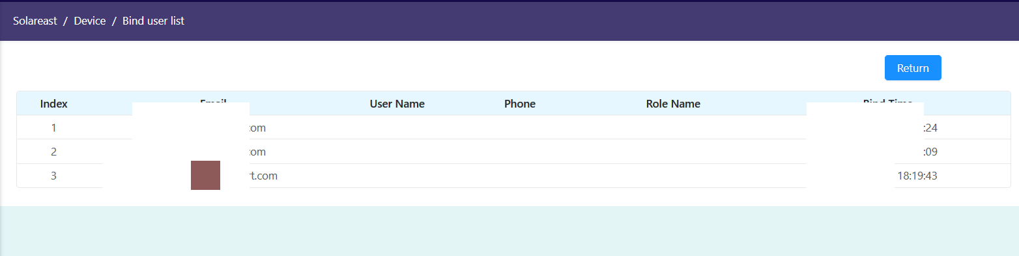

1. delete device

Click "Delete" in the device list to delete the current device, as follows:

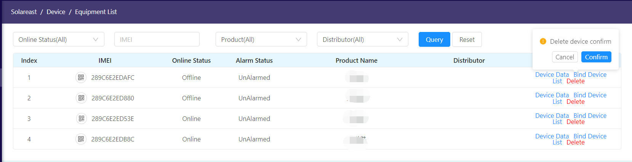

After clicking "Confirm", the device will be deleted from the system .

### 4.2 Equipment Storage

The administrator can use the IMEI list of the WiFi module to import the equipment to be produced into the system through this function for subsequent management. When importing, you need to specify the product type, and the dealer information cannot be left unselected .

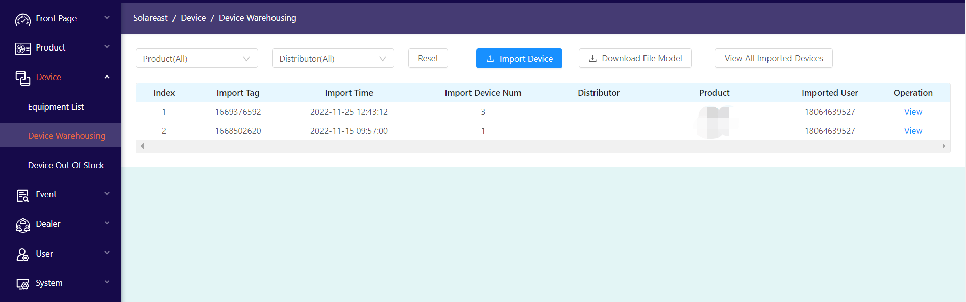

Filter by product, distributor. You can view a single imported device as well as all imported devices.

By clicking "Download Import Template", you can download the excel template used to import the device. The imported device template is as follows:

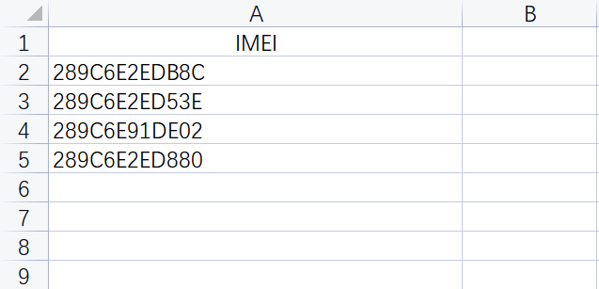

### 4.3 Equipment Out of the Warehouse

Use this function to assign devices to dealers.

After selecting the designated dealer, check the equipment to release the warehouse. After the warehouse is released, the dealer account logs in to the system, and you can see the equipment shipped to your own account in the equipment list.

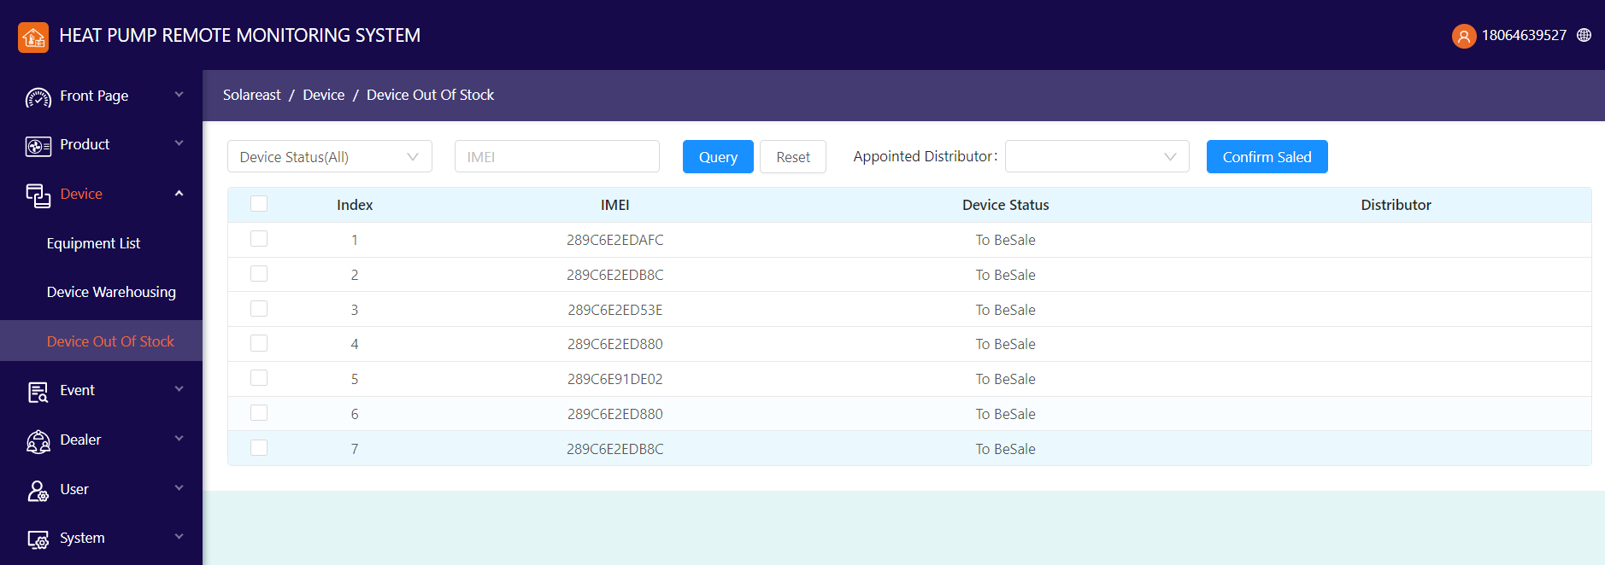

# 5. Events

### 5. 1 Alarm List

Display the alarm records of the device in the form of a list, as shown in the figure below:

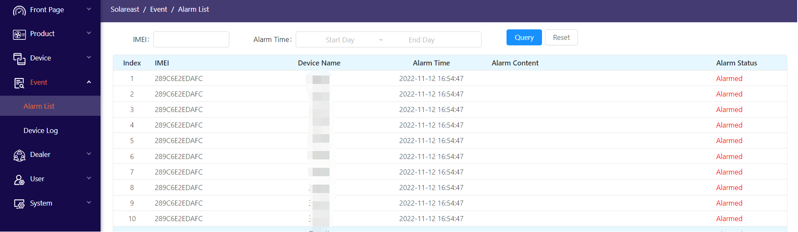

It can be queried according to IMEI and alarm time.

### 5.2 Device Logs

Information reported by the device in the form of a list , and display the original binary data:

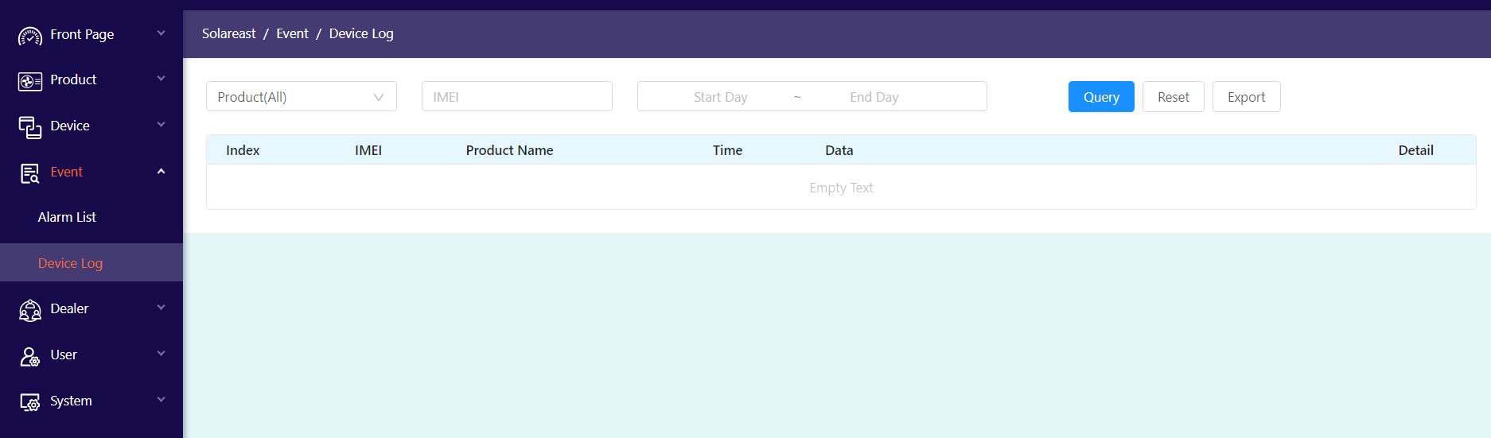

Filter queries can be performed according to product, IMEI and time period.

Click "View" to display the parsed content of the current line of binary data .

Click the "Export" button to save the analyzed value of the device log data to the excel table

# 6. Dealer Management

### 6.1 Dealer List

Display dealer data in list form. Filter query display and operation can be performed according to dealer name and dealer grade . Resellers can be deleted.

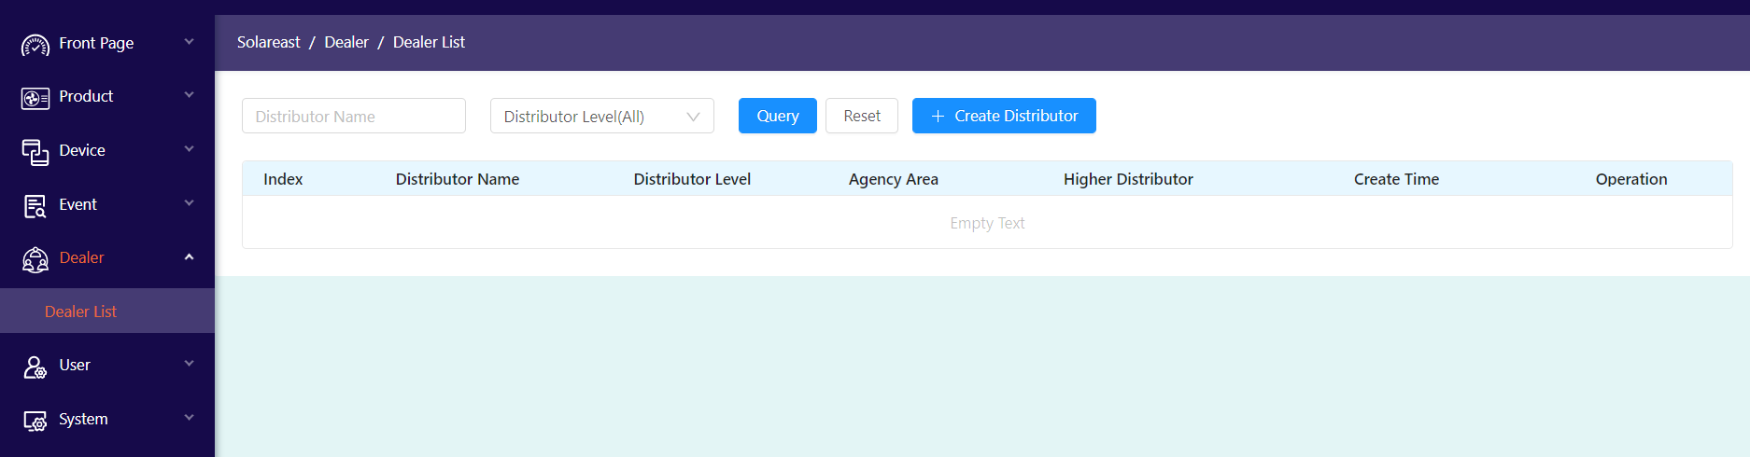

### 6.2 Create and Edit

Click "Create a dealer" on the dealer list page to open the dealer creation page, as shown below:

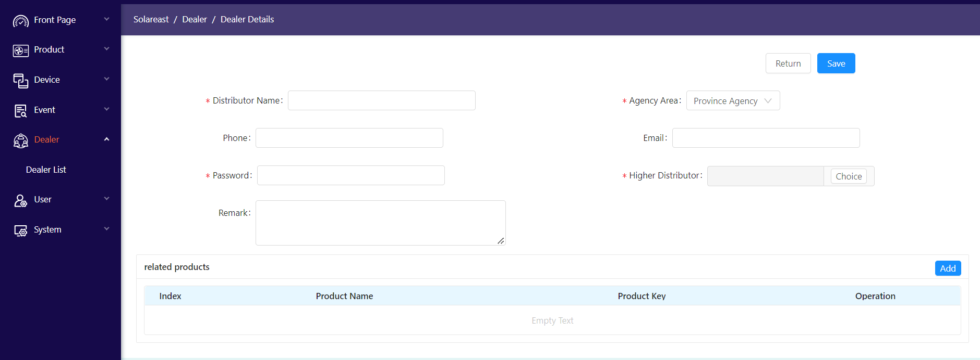

A parent distributor and associated products can be designated for this distributor.

On the dealer list page, click on the dealer name to edit the dealer information.

# 7. User Management

### 7.1 User List

the user information registered through the APP in the form of a list :

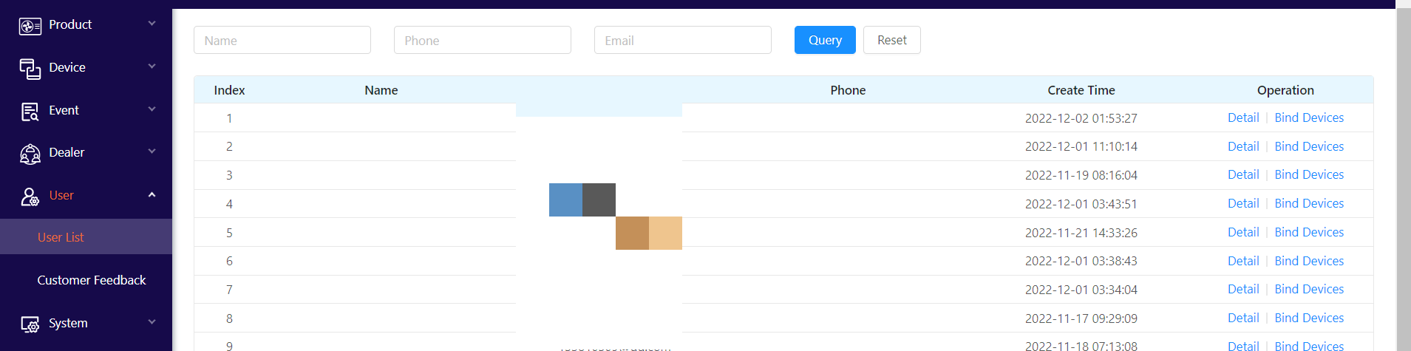

It can be filtered according to the mobile phone number and user name, and the list of devices bound to the user can be viewed .

You can unbind a device bound to the user .

# 8. System

### 8.1 Account

Manage other system accounts except dealers. Display account information in the form of a list, which can be filtered according to roles and user names, as follows:

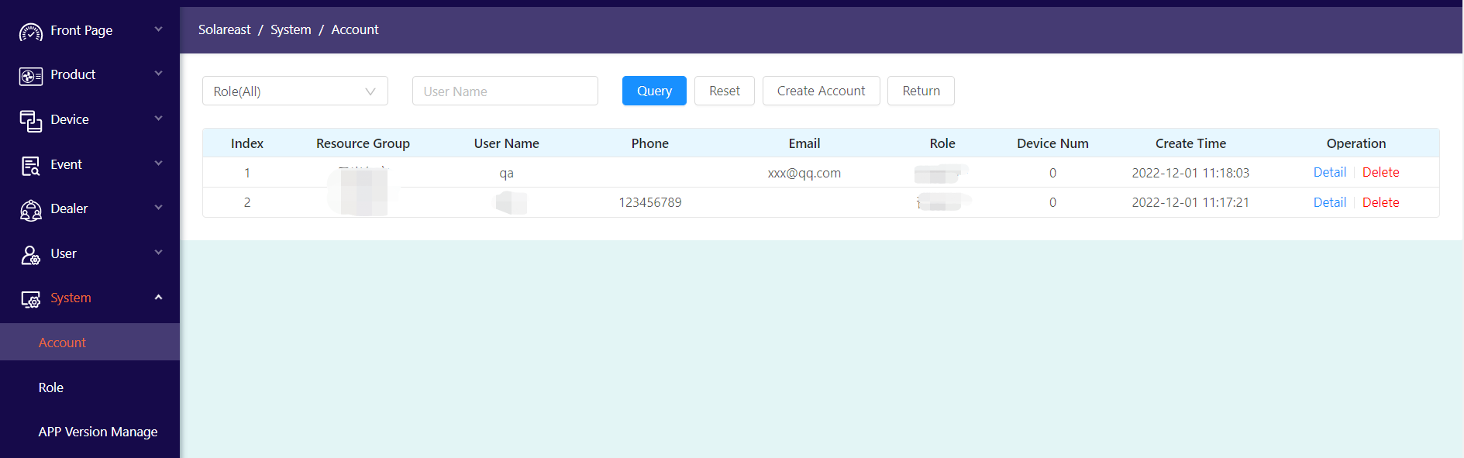

Accounts can be deleted.

Click "Create Account" to open the account page to create a new user account.

Click "Details" in the account list to open the account details page, edit and save the account information.

### 8.2 Role Management

In this function, the roles required for system management are defined, and the access rights of system functions and operation rights of some functions are specified for the roles.

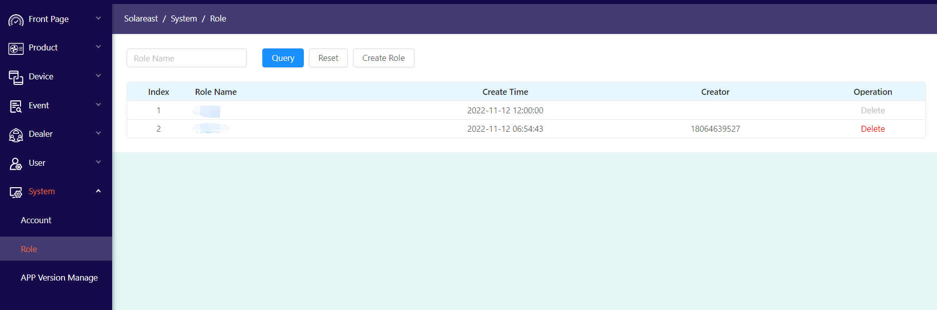

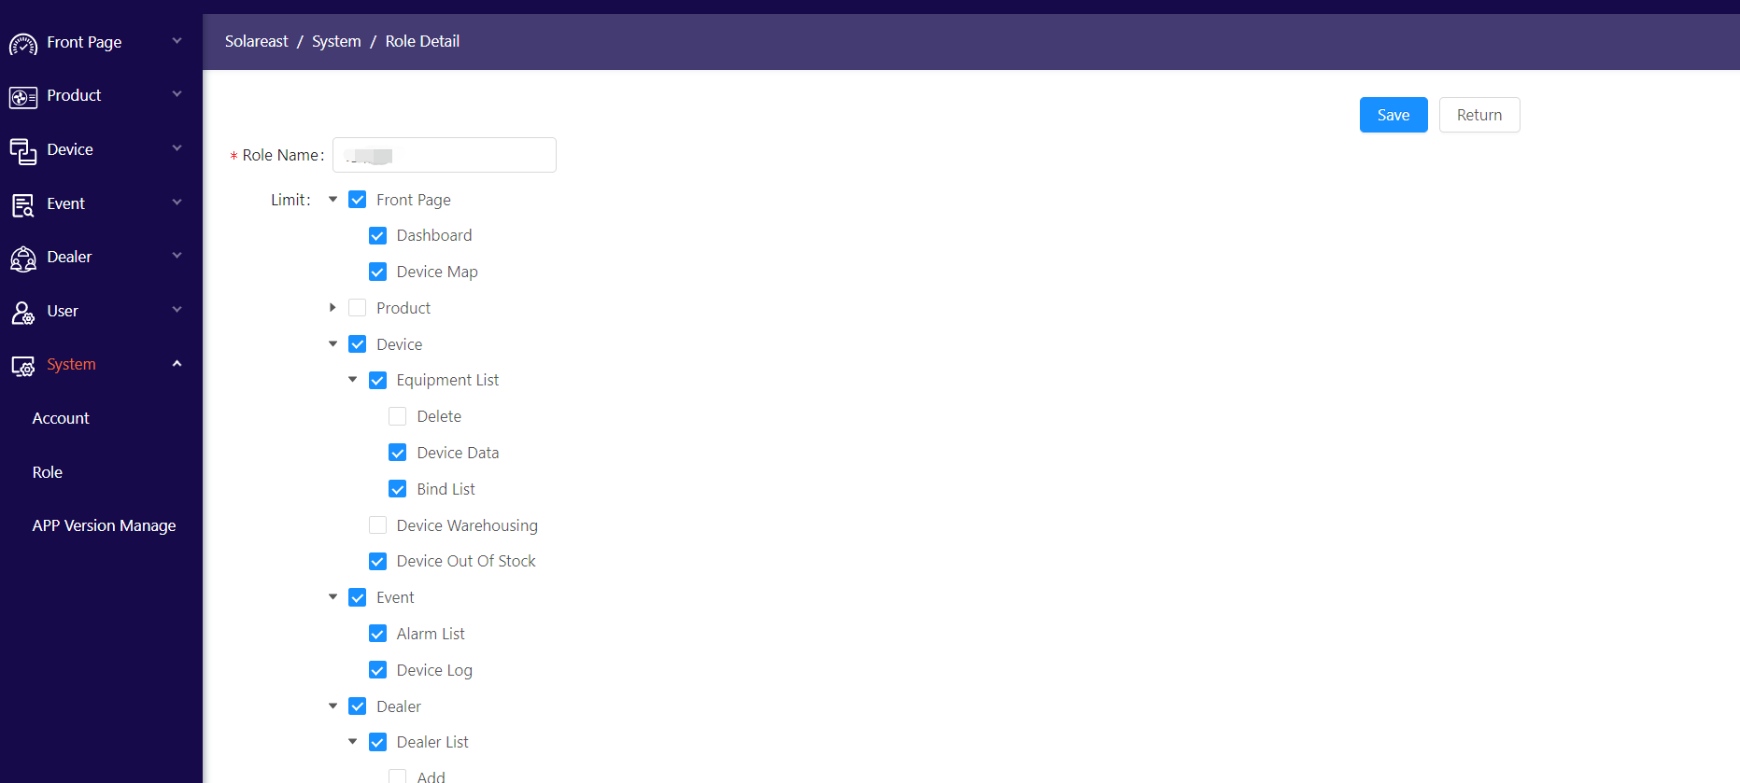

Checking the box means assigning permissions to this role. A role is assigned to an account when the account is created.

### 8.3 APP Management

This function is used to manage the corresponding APP information in the system.

